The New Alphabet
A is for apple, and B is for boat, that used to be right, but now it won't float! Age before beauty is what we once said,but let's be a bit more realistic instead.


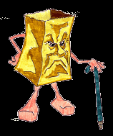
Now The Alphabet:

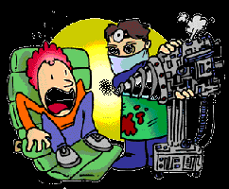
A's for arthritis; B's the bad back, C's the chest pains, perhaps car-di-ac?

D is for dental decay and decline, E is for eyesight, can't read that top line! F is for fissures and fluid retention, Gis for gas which I'd rather not mention.
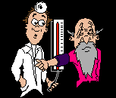H high blood pressure--I'd rather it low; I for incisions with scars you can show. J is for joints, out of socket, won't mend, K is for knees that crack when they bend. L 'S for libido, what happened to sex? M is for memory, I forget what comes next. N is neuralgia, in nerves way down low; O is for osteo, bones that don't grow!
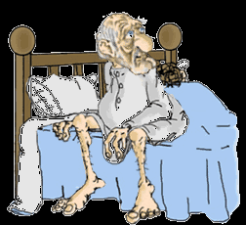
P for prescriptions, I have quite a few, just give me a pill and I'll be good as new! Qis for queasy, is it fatal or flu? Ris for reflux, one meal turns to two.

S is for sleepless nights, counting my fears, T is for Tinnitus; bells in my ears! U is for urinary; troubles with flow; Vfor vertigo, that's 'dizzy,' you know.

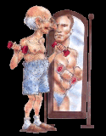

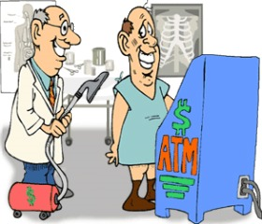
W for worry, now what's going 'round? X is for X ray, and what might be found. Yfor another year I'm left here behind, Z is for zest I still have-- in my mind!

I've survived all the symptoms, my body's deployed, and I'm keeping twenty-six doctors fully employed!

